ELE888 Intelligent Systems

Lab 3: Multilayer Neural Network (MNN)

# Introduction

The objective of this lab is to implement a multilayer neural network (MNN) using an XOR truth table and wine data set obtained from the following link as training sets:

http://archive.ics.uci.edu/ml/machine-learning-databases/wine/

# Theory

## Multilayer Neural Network and Back propagation

MNN consists of an input layer, output layer , and hidde layers. Data traverses through these layers changing with weights that connects neuron from one layer to the next. MNN is useful in classifying data that is not linearly separable.

The goal is to estimate the weight vectors of the network for a sigmoid activation function [1] described in the equation below:

$f(x) = atanh(bx)$

where *a = b = 1*

For this lab, the MNN will be using batch backpropagation algorithm to train itself. The algorithm is described below:

1. begin initialize network topology(# hidden units), w, criterion θ, η, r ← 0

2. do r ← r + 1 (increment epoch)

3. m← 0; ∆wij ← 0; ∆wjk ← 0

4. do m← m+ 1 5. xm ← select pattern

6. ∆wij ← ∆wij + ηδjxi; ∆wjk ← ∆wjk + ηδk yi

7. until m = n

8. wij ← wij +∆wij; wjk ← wjk +∆wjk

9. until ∇J(w) < θ

10. return w

11. end

where the sensitivity of unit k is given by

$δ_{k}=(t_{k}-z_{k})(f'({net}_{k}))$

and the sensitivity for a hidden unit is given by

$δ_{j}=f'({net}_{j})\sum_{k=1}^{e}{}w_{kj}δ_{k}$

# Results

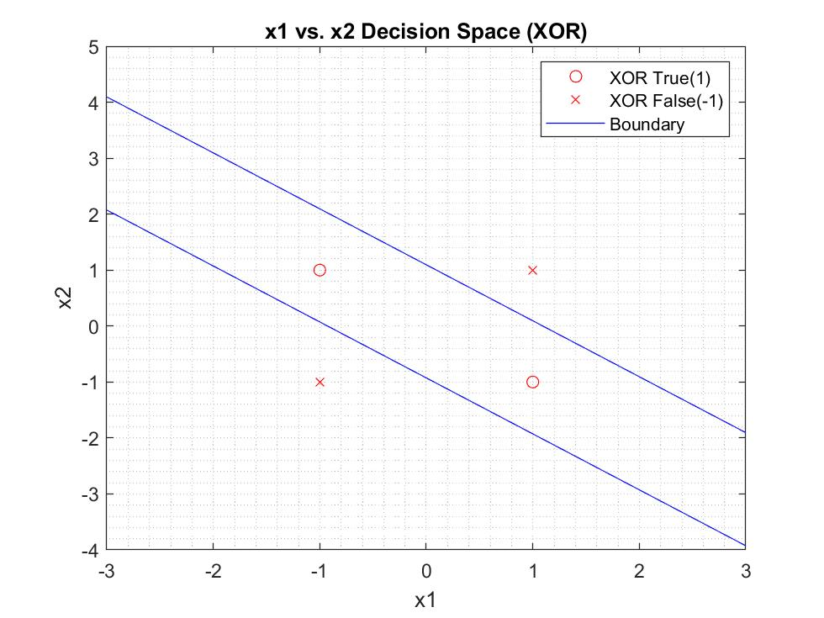

Figure 1. x1 vs x2 Decision space of the XOR data test

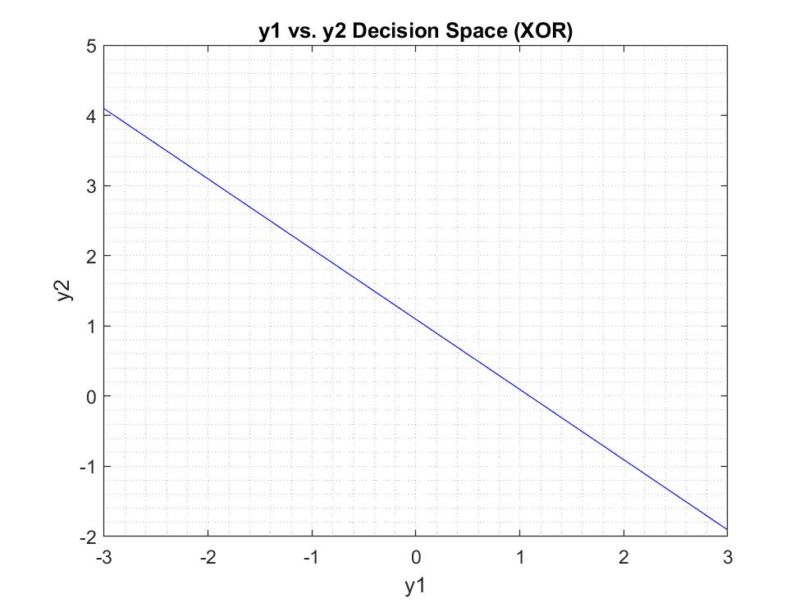

Figure 2. y1 vs y2 Decision space of the XOR data test

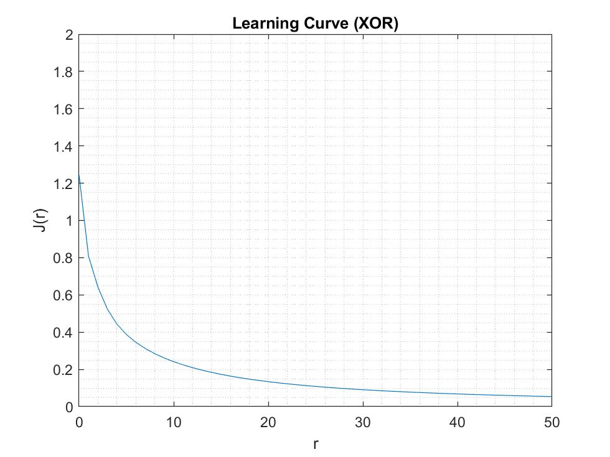

Figure 3. learning curve of MNN using XOR data set

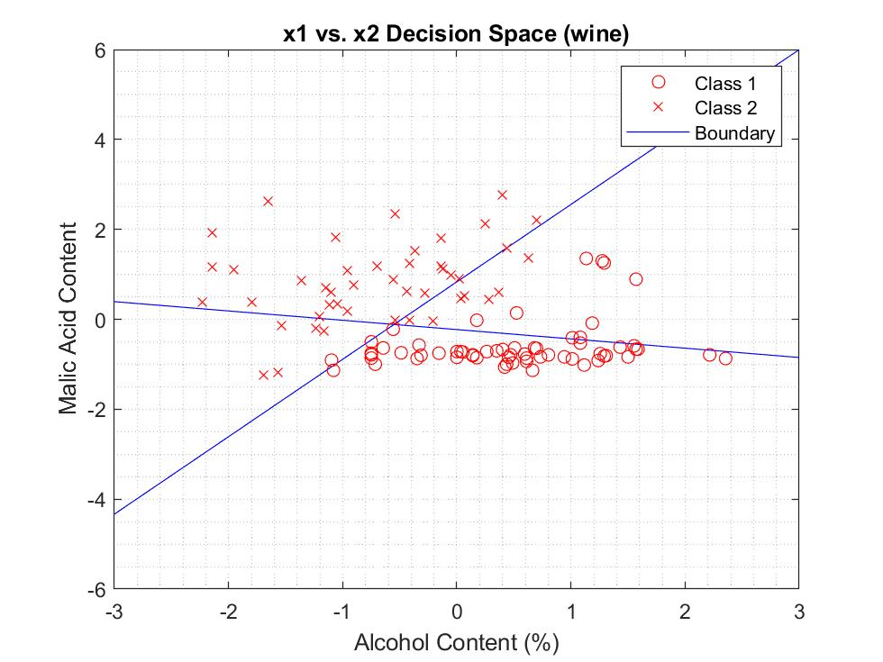

Figure 4. x1 vs x2 Decision space of the wine data test

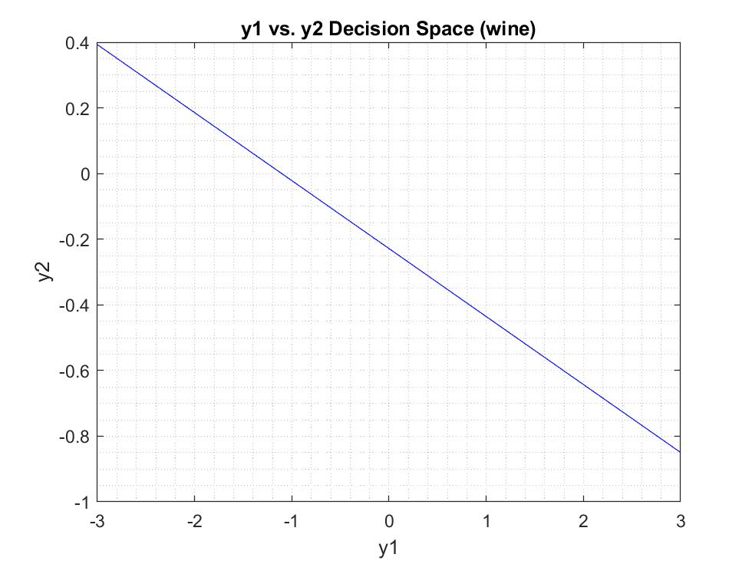

Figure 5. y1 vs y2 Decision space of the wine data test

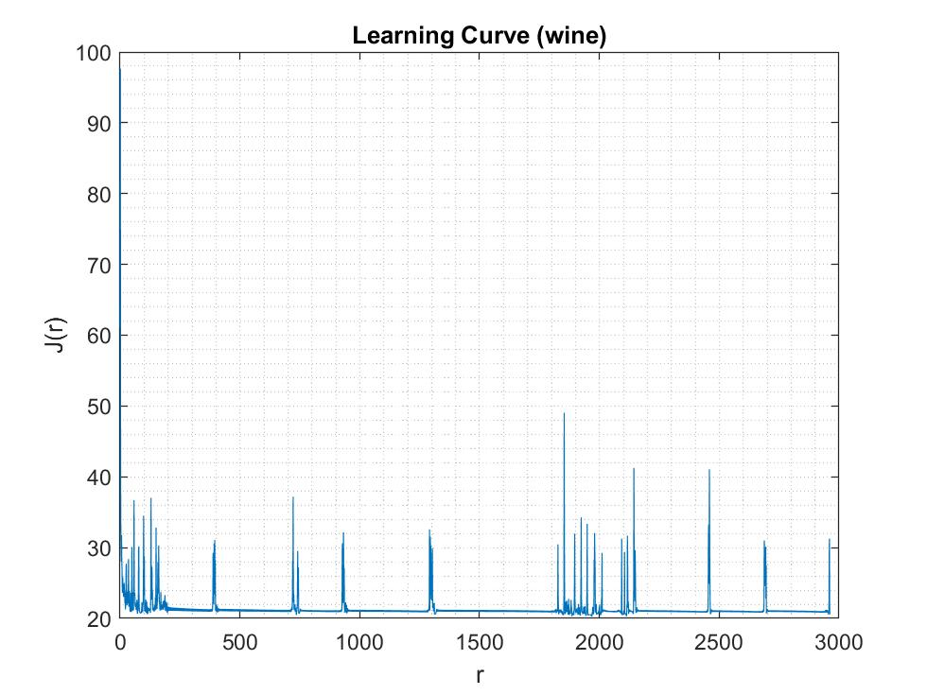

Figure 6. MNN learning curve using the wine data set

|  |  |  |  |
| --- | --- | --- | --- |
| Data | Final Weight Vectors | Iterations | Accuracy |
| XOR | wj1=[1.19, 1.28, 1.28] | 55 | 100% |
| wj2=[-1.65, 1.50, 1.50] |
| wk=[-1.35, 1.50, -1.52] |
| Wine | wj1=[1.41, 2.91, -1.69] | 734 | 87.85% |
| wj2=[2.25, 2.03, 9.82] |
| wk=[-1.45, 4.53, -3.89] |

Table 1. Final weight vectors and number of epoch iterations for the XOR and wine dataset

# Conclusion/Discussion

From Table 1. the MNN was able to obtain the target output from its respective input all correctly thus giving us 100% accuracy. On the other hand, the wine data was not able to classify all the data correctly outputting 87.85% accuracy.

The convergence was reached after 55 epoch iterations for the XOR data set and 734 for the wine data set. This is to be expected since the wine data is a larger data set with more complex data mapping.

# Reference

[1] N. Zhang, ”ELE888/EE8209 – Intelligent Systems – Student Lab Manual,” Department of Electrical and Computer Engineering, Ryerson University, Toronto, Ontario, March 2019.